**Velocity Control**

**HexaMotor**

**Experiment objectives:**

• Introduction to DC motor dynamic equations.

• Coulomb Friction identification and handling

• System identification using open loop step response, model validation.

• System identification using frequency response, model validation.

• Velocity control implementation. Proportional, Proportional - Integral control loops.

• Controller performance under load.

# Introduction

DC motors are electromechanical devices that convert electrical energy into mechanical energy, using principles of electromagnetism. They are known for their simple construction, high reliability, and ease of control. These features make them suitable for various applications, from small electronic devices to large industrial machinery.

## DC motor equations

The electric equivalent circuit of the armature and the free-body diagram of the rotor are shown in Figure 2.

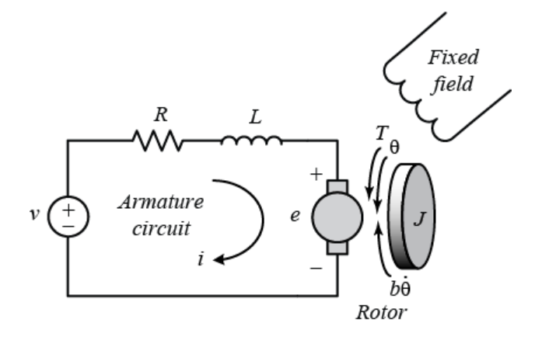

Figure 2: Electric equivalent circuit of a dc motor

**V** - Applied Voltage: The voltage applied across the motor's terminals. It is the input to the system and determines the driving force behind the motor.

**i** - Armature Current: The current flowing through the armature winding, responsible for creating the magnetic field that drives the motor.

**R** - Armature Resistance: The resistance of the armature winding, which opposes the flow of current.

**L** - Armature Inductance: The inductance of the armature winding, which determines how quickly the current can change in the coil.

**Vemf** - Back Electromotive Force (EMF): Voltage generated by the motor's rotation, opposing the applied voltage.

**Kt** - Torque Constant: A factor that relates the motor's torque output to its current. It depends on the motor's construction.

**Kb** - Back EMF Constant: A factor that relates the motor's back EMF to the angular velocity. It often equals the torque constant in many DC motors.

**T** - Torque: The twisting force exerted by the motor on its shaft.

Tfriction - Friction Torque: The torque opposing the motor's rotation due to various frictional effects.

**J** - Moment of Inertia: A measure of the motor's resistance to changes in its rotational speed. It depends on the distribution of mass in the rotating parts.

**ω** - Angular Velocity: The rate of rotation of the motor's shaft, often the controlled output in velocity control systems.

**B** - Damping Coefficient: A parameter representing the viscous friction in the system. It characterizes how the frictional forces are proportional to the angular velocity.

**Tcoulomb** - Coulomb friction.

**s -** Complex Frequency (Laplace Variable): In the context of the transfer function, s is a complex variable used in the Laplace transform.

**Voltage Equation:**

$V=Ri+L\frac{di}{dt}+K_{e}ω$

where V is the applied voltage, R is the armature resistance, i is the armature current, L is the armature inductance, Kb is the back EMF constant, and ω is the angular velocity.

**Torque Equation:**

$T=K_{t}i-T_{friction}- J\frac{dω}{dt}$

where T is the torque, Kt is the torque constant, Tfriction is the friction torque, J is the moment of inertia, and $\frac{dω}{dt}$ ​ is the angular acceleration.

**Friction Model:**

$T_{friction}=Bω+T_{coulomb}$

By substituting the expressions for torque and friction into the torque equation and solving for the differential equation relating the applied voltage to the angular velocity, we obtain:

$LJ\frac{d^{2}ω}{dt^{2}}+\left(RJ+BL\right)\frac{dω}{dt}+(BR+K_{t}K_{e})ω=K_{t}V$

Now, the transfer function relating the applied voltage V(s) to the angular velocity Ω(s) in the Laplace domain (assuming zero initial conditions) is:

$G\left(s\right)=\frac{K_{t}}{LJs^{2}+\left(Rj+BL\right)s+(BR+K_{t}K_{e})}$

## First order approximation:

Armature Inductance (L): The inductive term $L\frac{di}{dt}$ ​ in the voltage equation is often neglected. This is under the assumption that the armature inductance is small compared to the resistance, meaning that the electrical dynamics are much faster than the mechanical dynamics.

**First-Order Transfer Function:**

$G\left(s\right)=\frac{K_{t}}{\left(RJ\right)s+(BR+K_{t}K_{e})}$

This first-order model offers a simpler representation of the DC motor's dynamics and is useful for preliminary control design or when the details of the electrical subsystem are not critical. It captures the main characteristics of the motor's velocity response but omits some of the subtler dynamics present in the full second-order model.

**For additional reading consider the following links:**

DC motor velocity model:

<https://ctms.engin.umich.edu/CTMS/index.php?example=MotorSpeed&section=SystemModeling>

System analysis:

<https://ctms.engin.umich.edu/CTMS/index.php?example=MotorSpeed&section=SystemAnalysis>

## Coulomb friction

Coulomb friction is distinctive from viscous damping, as it remains constant regardless of the speed of the motor. It contributes to non-linearity in the system and can lead to challenges in maintaining precise control, especially at low speeds.

Measuring Coulomb friction in a DC motor is essential for designing effective control strategies. One common method to identify this friction involves applying a small, controlled voltage to the motor and observing the threshold voltage at which the motor begins to rotate. By relating this threshold voltage to the known torque-to-current relationship, the Coulomb friction torque can be quantified.

## Step response modeling

Step response modeling, commonly referred to as the "bump test," is a straightforward examination grounded in the step response characteristics of a stable system. In this test, a step input is applied to the system, and the subsequent response is observed and recorded. To illustrate this concept, imagine a system defined by a particular transfer function:

$G\left(s\right)=\frac{K}{τs+1}$

The step response in the shown figure is generated using K=10 rad/V and $τ=0.1s$.

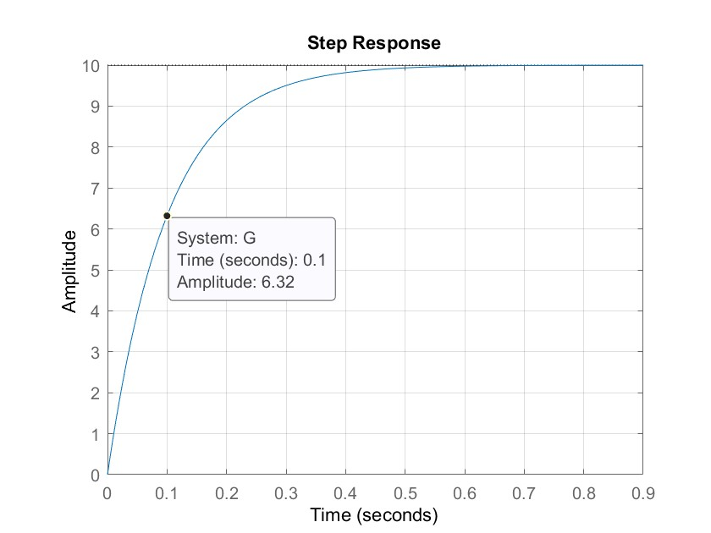

Figure 3: Step response of eq1.7 with K=10, τ=0.05s.

The time constant τ is a measure of how fast the system responds to a change in input. It's defined as the time it takes for the system's response to reach approximately 63.2% of its final value (steady-state value) after a step change in input.

To see why it is the case lets evaluate a first-order linear system that has the general form of a time constant τ and can be described by the following first-order differential equation:

$τ\frac{dy(t)}{dt}+y(t)=Ku(t)$

If the system is subjected to a step input of magnitude A, the response y(t) can be described by:

$y\left(t\right)=KA(1-e^{-\frac{t}{τ}})$

By evaluation the response at $t=τ$ we get:

$y\left(τ\right)=KA(1-e^{-\frac{τ}{τ}})≈KA∙0.632$

## Frequency response modeling

System analysis with a sinusoidal input provides insights into the motor's frequency response, resonance behavior, and the effect of damping. The motor's transfer function can be used to investigate how different frequencies of the sinusoidal input are amplified or attenuated, revealing information about the stability, bandwidth, and transient response of the system.

When a sine wave is used as an input for a DC motor, the motor's output results in a sinusoid of the same frequency but is scaled and delayed. As illustrated in Figure 4, the length of one full period of the sinusoid is represented by t1​, while t2​ indicates the time delay between the input voltage signal, Vm​, and the corresponding scaled output speed signal, $ω_{m}$.

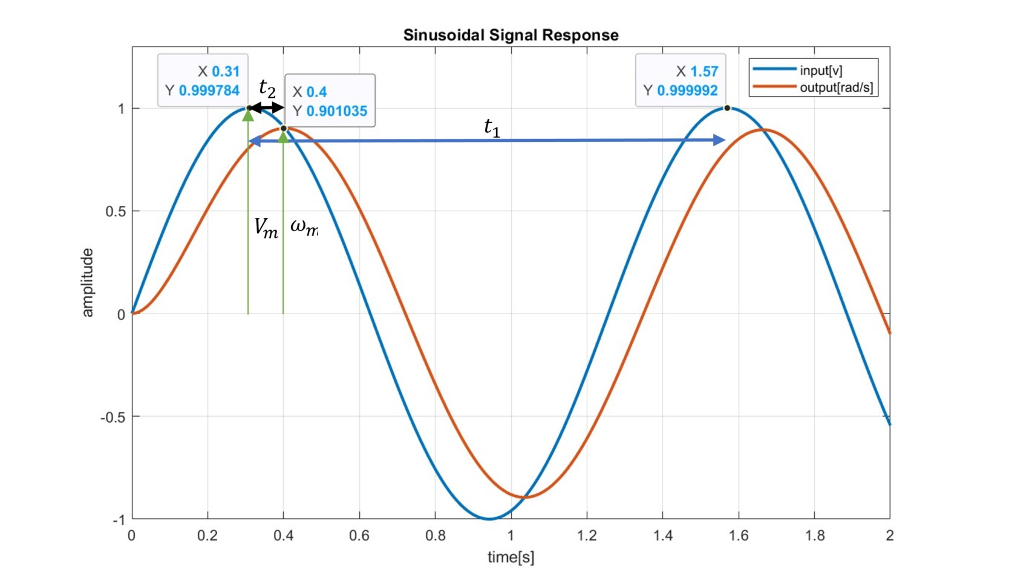

Figure 4: System response with a sinusoidal signal

The magnitude response of the resulting output changes with respect to the frequency of the applied sinusoid and can be used to find the time constant τ of the DC motor with the first order approximation. In addition, a bode plot of the system`s magnitude response can be obtained.

$G\left(s\right)= \frac{ω_{m}(s)}{V_{m}(s)}=\frac{K}{τs+1}$

Substituting s = jω the magnitude of the frequency response at a frequency ω of the motor input voltage is then defined as

$\left|G\left(s\right)\right|=\left|\frac{ω_{m}(jω)}{V_{m}(jω)}\right|=\left|\frac{K}{τjω+1}\right|= \frac{K}{\sqrt{τ^{2}ω^{2}+1}}$

The system’s steady state (or low frequency) gain can then be obtained by setting *ω* = 0, applying a constant signal:

$K=\left|G\left(0\right)\right|$

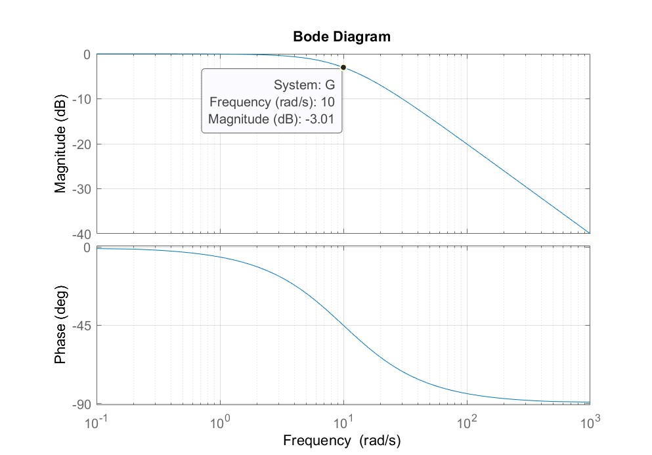

The Bode plot includes a vital feature known as the cutoff frequency, denoted by $ω_{c}$ ​. It's the frequency where the system's gain is 3 dB below its maximum steady-state gain. This 3 dB drop corresponds to the system's half-power point, leading to a value of approximately -3.01 dB, or equivalently a magnitude of approximately $1/\sqrt{2}$ ≈0.7072​1​≈0.707, or -3.01 dB in terms of the maximum system gain. The cutoff frequency is synonymous with the system's bandwidth and serves as an indicator of the speed at which the system reacts to an input.

## PID controller

The PID controller, which stands for Proportional-Integral-Derivative, is one of the most widely used feedback control algorithms in industry. Its popularity stems from its effectiveness in a broad range of applications and its relatively straightforward tuning process.

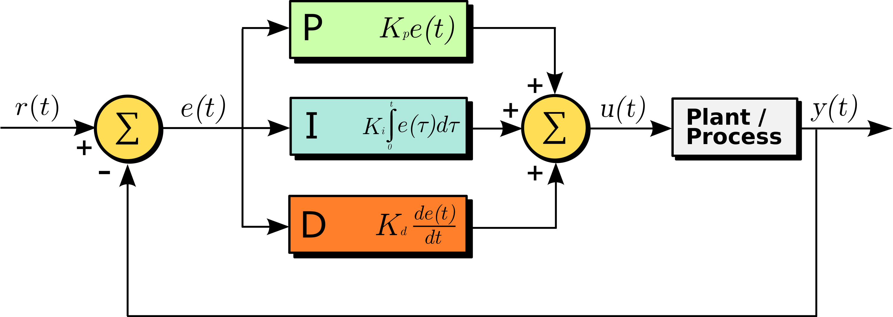

Figure 3: Block diagram of a PID controller

$u\left(t\right)=K_{p}e\left(t\right)+K_{i}\int{e\left(t\right)dt}+K_{d}\frac{de(t)}{dt}$

The PID controller consists of three main components:

**Proportional (P)**: This part produces a control action that's directly proportional to the error between the setpoint and the measured process variable. The proportional gain Kp determines how aggressively the controller responds to an error.

**Integral (I):** The integral term is concerned with the accumulated error over time. If there is a persistent, steady-state error, the integral action will build up and eliminate it.

**Derivative (D):** The derivative action provides a control effort to counteract the rate of error change. It anticipates the future error by its rate of change and provides control action to prevent it from occurring.

**For additional reading consider the following links:**

Introduction: PID Controller Design<https://ctms.engin.umich.edu/CTMS/index.php?example=Introduction&section=ControlPID>

## Proportional speed control

In proportional control, the control action is directly proportional to the error between the desired set point and the actual measured value, in this case, the motor speed. The equation for the control action is given by: $u\left(t\right)=K_{p}e\left(t\right)=K_{p}(r\left(t\right)-y\left(t\right))$,

$K_{p}$ is the proportional gain. $r\left(t\right)$ = $ω_{d}(t)$ is the the desired angular velocity, $y\left(t\right)=ω_{m}(t)$ is the measured angular velocity and $u\left(t\right)=v_{m}(t)$ is the control impute (the voltage applied to the motor).

The close loop transfer function can be derived

$T\left(s\right)= \frac{Y\left(s\right)}{R\left(s\right)}=\frac{P(s)∙C(s)}{1+P(s)∙C(s)}=\frac{{K∙K}_{p}}{τs+1+{K∙K}_{p}}$

Whereas P(s) is the first order approximation of the dc motor. And $C\left(s\right)=K_{p}$ represent the controller transfer function.

## Final value theorem

The Final Value Theorem states that if a system is stable and if the limit exists, the steady-state value of a time-domain function $f\left(t\right)$ can be found directly from its Laplace Transform $F\left(s\right)$. The theorem is given by:

$\lim_{t→∞}{f}\left(t\right)=\lim_{s→0}{s}∙F\left(s\right)$

## Steady state error

Steady-state error is the difference between the desired and actual velocity of the DC motor once the transients have died down, and the system has reached its steady-state condition. The main reason for this steady-state error in proportional control lies in the nature of the control law itself. Since the control action is proportional to the error, when the error reduces to zero, so does the control input. In physical systems like a DC motor, there may be disturbances, such as friction, that require continuous control effort to overcome. If the control input becomes zero, these disturbances may cause the system to drift away from the desired set point.

Given a step input $R\left(s\right)=\frac{1}{s}$ The error transfer function can be derived as:

$E\left(s\right)=R\left(s\right)-Y\left(s\right)= R\left(s\right)-T\left(s\right)∙R\left(s\right)=\frac{1}{s}-\frac{{K∙K}_{p}}{s(τs+1+{K∙K}_{p})}$

By applying the final value theorem:

$\lim_{t→∞}{e}\left(t\right)=\lim_{s→0}{s}∙E\left(s\right)=\lim_{s→0}{s}\left(\frac{1}{s}-\frac{{K∙K}_{p}}{s\left(τs+1+{K∙K}_{p}\right)}\right)=1-\frac{{K∙K}_{p}}{1+{K∙K}_{p}}$

The steady stae error is given by:

$e_{ss}=1-\frac{{K∙K}_{p}}{1+{K∙K}_{p}}$

# Pre Lab

## Step response modeling

1. Given the first order approximation of a dc motor, what would be the values of K and $τ$ (give parametric solution).
2. Using Matlab, plot the step response of the following first order system $G\left(s\right)=\frac{1}{0.1s+1}$, Mark the time constant $τ$ and the steady state gain K.

## Frequency response modeling

1. Using Matlab plot the response of the system $G\left(s\right)=\frac{1}{0.1s+1}$ to various sin inputs, calculate the gain change as a function of frequency. You can use the "lsim” function in Matlab to simulate a system response to an arbitrary input signal in the time domain. Or implement it in Simulink.
2. Calculate the cutoff frequency $ω_{c}$ and plot the system`s sinusoidal response at this frequency.
3. Using the first order approximation $G\left(s\right)=\frac{K}{τs+1}$ Derive an expression to determine $τ$ based on $ω_{c}$ Hint: $\left|G\left(ω_{c}\right)\right|=\frac{1}{\sqrt{2}}\left|G\left(0\right)\right|$

## PID controller

1. Calculate the parametric steady state error for the given system $G\left(s\right)=\frac{1}{0.1s+1}$ in a close loop using a proportional gain controller Kp and a step response input
2. Plot the response of the close loop system using Kp=10, compare the steady state value to the theoretical.

**Bonus Questions:**

1. Calculate the transfer function of a closed loop velocity controlled dc motor with a PI Controller using the first order approximation for the dc motor transfer function.
2. Calculate the steady state error for the above.
3. For the given system: $G\left(s\right)=\frac{1}{0.1s+1}$ Design a PI controller with a rise time of up to 0.1s and overshoot of up to 15%.
4. Consider the DC motor equations, what will happen to the time constant $τ$ in case an additional rotating mass will be added to the motor. Hint: consider what will happen to the inertia **J.**

# In Lab

## Coulomb friction

Jfghjgfjfgjfgjghjfghj